Association of Computer Professional (ACP)

Advanced Diploma Project 1
Java Editor
July 2011

Submitted By
Mohammad Bappy Chowdhary
ACP Membership Number: S12237

London Trinity College (Centre Number: 385)

Index
Contents Page No
Introduction ------------------------------------------------------------------------------------ 3
The write program Outline --------------------------------- -- - --------------------------- 3
The Read Program Outline ----------------------------------------------------------------- -4
The File Edit program Outline -------------------------------------------------------------- 4
The Technical Specification ----------------------------------------------------------------- 5
Variable List ------------------------------------------------------------------------------------- 5
Packages ----------------------------------------------------------------------------------------- 5
Classes --------------------------------------------------------------------------------------------5
File Organisation -------------------------------------------------------------------------------6
Software used for development ----------------------------------------------------------- 6
Run time requirements----------------------------------------------------------------------- 6
Hardware requirements --------------------------------------------------------------------- 6
Software ----------------------------------------------------------------------------------------- 6
Write module -----------------------------------------------------------------------------------6
Introduction ------------------------------------------------------------------------------------- 6
Input Data ----------------------------------------------------------------------------------------7
Screen layout ------------------------------------------------------------------------------------7
Flow Chart ----------------------------------------------------------------------------------------8
Code ----------------------------------------------------------------------------------------------- 9
Test Result ---------------------------------------------------------------------------------------10
Read Module ----------------------------------------------------------------------------------- 13
Introduction ------------------------------------------------------------------------------------- 13
Input Data ---------------------------------------------------------------------------------------- 13
Screen Layout ----------------------------------------------------------------------------------- 13
Flow Chart ----------------------------------------------------------------------------------------14
Code ----------------------------------------------------------------------------------------------- 15
Test Result ---------------------------------------------------------------------------------------16
Edit Module -------------------------------------------------------------------------------------17
Introduction -------------------------------------------------------------------------------------17
Input Data --------------------------------------------------------------------------------------- 17
Screen Layout ---------------------------------------------------------------------------------- 18
Flow Chart -------------------------------------------------------------------------------------- 20
Code ---------------------------------------------------------------------------------------------- 22
Test Result --------------------------------------------------------------------------------------24
Validation --------------------------------------------------------------------------------------- 30
Conclusion -------------------------------------------------------------------------------------- 30
Limitations -------------------------------------------------------------------------------------- 30
Improvements --------------------------------------------------------------------------------- 30
Examiner’s Comments ----------------------------------------------------------------------- 30

Introduction:
User input records will be written, they will be readable and editable using java programming language. The project will be performed within MS-DOS prompt such as giving input and saving them and having a output which are editable.

Write Program:
File containing records such as names will be stored using this program.

Read Program
Written file will be read using this particular program.

Edit Program:
File already made using the write program will be edited with this particular code.

The Write program outline

Input | Processes
- File Name (without extension .txt).  - The data fields will be “names” as a record list. | - Validity of the file name  - Calculating the bytes entered by the user.  - Calculate the size of the entire file.  .
Files | Output
- Bappy1.txt | - A record list of name.  - The size of the file.  - A message which confirm the data has been written.

The Read program Outline

Input | Process
- File Name (without extension .txt). | - Validity of the file name.  - Searching for the file.  - File content which is name would be reading after another.
Files | Output
- Bappy2.txt | - A list record names one after another.  - A message saying end of data reading.

The File Edit program outline

Input | Process
- File Read Name (without extension .txt).  - File Read Name (without extension .txt).  - Inputting the “Name “field” when requested.  - Inputting the “Age “field” values when requested. | - Validation of the existence of Read file and the creation of Write file.  - Reading the names one after another.  - Adding the field “Age” to a displayed “name” record.  - Deleting a field record “A Name” by typing -5.  - Inserting a new record with its “name” and “Age” field when typing 1.
Files | Output

Technical Specification
The programs will be written in most platform independent language which is java.
The entire file required to run the program are attached with this documentation.

Variable list
This data dictionary consist of variables which are common to all the modules
No. | Variable name | Variable type | Purpose | Example
1 | Cr | Character | To store characters. | A
2 | Dh | Integer | To store length of data. | 37
3 | T | String | To store concatenated data. | Devid Age 31
4 | FRead | String | To store file name to read data from. | Bappy1.txt
5 | FWrite | String | To store file name to write data in. | Bappy2.txt

Packages

The following files are used
No. | Package name | Purpose
1 | Java.io.* | User input and output has been used using IO.* package which is Input Output package of Java.

Classes
No. | Classes | Purpose
1. | Data Input Stream | The Data Input Stream class provides methods for reading primitive data types and lines of texts from an underlying input stream in a machine independent manner.
2. | Data Output Stream | The Data Output Stream class defines methods for writing primitive data types to an output stream in a machine independent manner.
3. | File Output Stream | To write something into the file.
4. | File Writer | The File Writer class allows us to write character files.
5. | Print Writer | The Print Writer class contains methods that make it easy to generate formatted output.

File organisation
When user uses the programs the data which are entered by the user or the data which are modified from the initial file are saved in a text file. The files are organised in a way that the data displayed in the identical way the files are displayed.
Bappy1.txt | Bappy2.txt
In Bappy1.txt when data is written after each record, carriage return (\r) and line feed (\n) are saved which bring the cursor to next line and starts new line. | In Bappy2.txt when data is written each record have age with it and between record and age there is a horizontal tab (\t) is followed by carriage return (\r) and the line feed (\n).

Software used for development
- Java Run time environment.
- Java SDK 1.6
- Eclipse IDE for Java
- Microsoft word 2007 is used for writing documentation.
- Microsoft Visio is used for drawing the Flowchart. Any intended modification in the Flowchart can only be done with Microsoft Visio.
- The platform was Microsoft Windows7 Ultimate using which the program was created and tested. Test results were functional and satisfactory.

Runtime requirements
Hardware requirements
A minimum required computer system is a Pentium 166 or better, 64 MB RAM or better with a compatible monitor and keyboard.

Software required
A JAVA virtual machine is required to develop the program which is normally present in Microsoft Windows7 Ultimate.

Write Module
Introduction
MS-DOS prompt window will ask the user to follow the right path to use the java program. After opening the file it will ask the user to give a file name, In this project I saved the file named “Bappy1”.

Then the program will ask to enter the data to store the file every line after line. After entering the data if the user press “b” from the keyboard then the program will be terminated and the size of the file will appear on the screen otherwise if the user press space button from the keyboard then the data entering will continue.

Input data
The following data is used
No. | Data | Purpose
1. | FWrite | To store file name to write data in.

Screen Layout

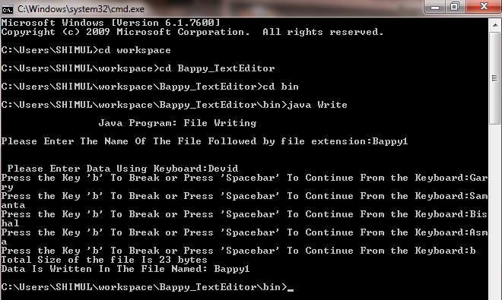

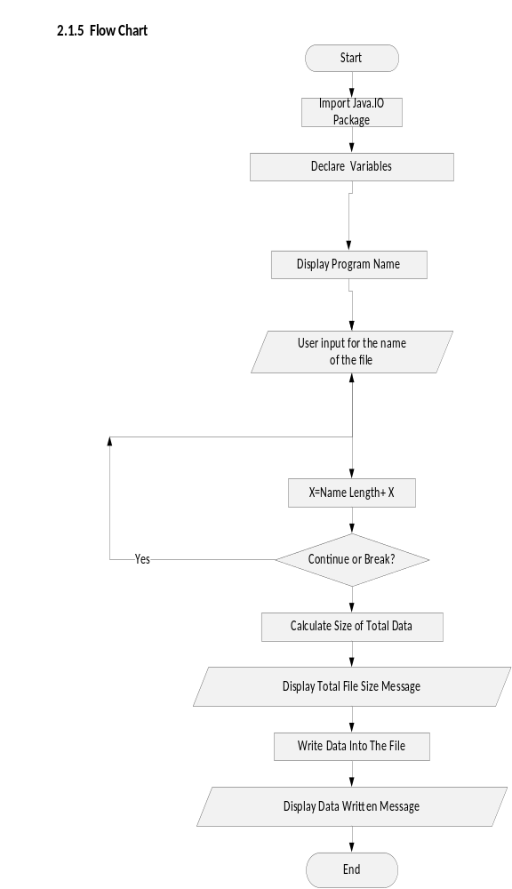

Java Code for the Write program:
import java.io.*;
public class Write {
public static void main(String gargs[])throws IOException{
BufferedReader br = new BufferedReader(new InputStreamReader(System.in));
System.out.println("\n\t\tJava Program: File Writing\n"); // Programme Heading
System.out.print("Please Enter The Name Of The File Followed by file extension:"); //To enter a file name buy user
String FWrite = br.readLine();
FileWriter fw = new FileWriter(FWrite);
PrintWriter pw = new PrintWriter(fw);
System.out.print("\n\n Please Enter Data Using Keyboard:"); //Input from User
char cr;
int dh = 0;
FileOutputStream fo = new FileOutputStream(FWrite);
DataInputStream inp = new DataInputStream(System.in);
do{
String T = br.readLine();
byte Ch[] = T.getBytes();
for(int i=0; i<Ch.length; i++)
pw.print((char)Ch[i]);
pw.println("");
dh = dh+Ch.length;
System.out.print("Press the Key 'b' To Break or Press 'Spacebar' To Continue From the Keyboard:"); // Decide either user wants to continue with the file or terminate.
cr = (char)System.in.read();
}
while(cr!='b');
System.out.println("Total Size of the file Is "+dh+" bytes");//Calculating the entire file size.
System.out.println("Data Is Written In The File Named: " +FWrite);
System.out.print("Press Any Key To Continue......");
fw.close();
}
}

Test Results
Test 1 to find out the file name right.

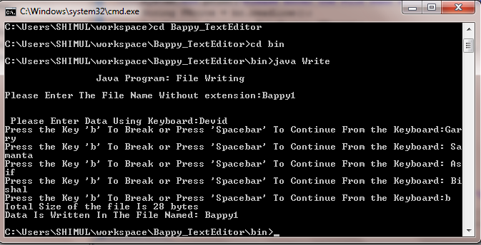

Test 2: for test the file not found exception.

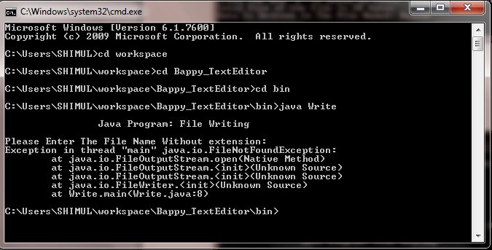

Test 3: To check either the program

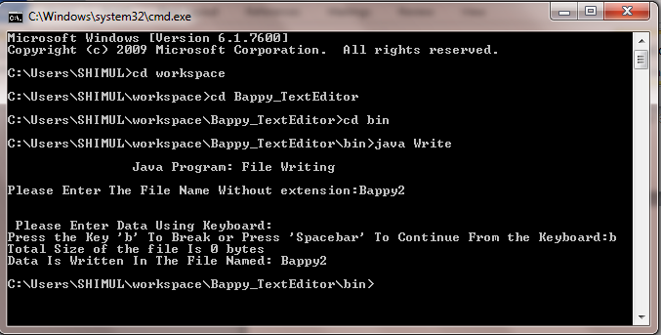

Test 4: to check out for the special symbol.
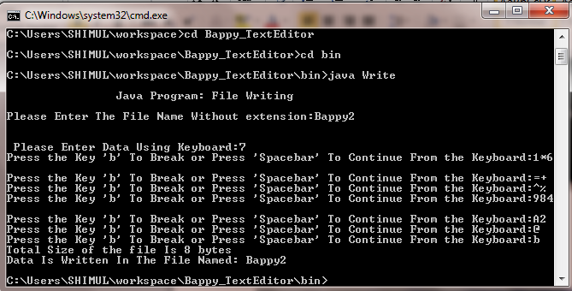

Output for test 5:
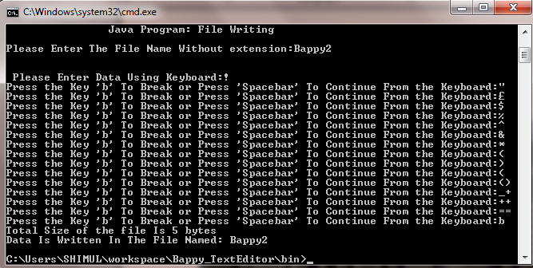

Summarised Test Results:
Test No. | Test Name | Expected Results | Actual Results | Comments
1 | Valid File name | No Error | As Expected | Valid Results
2 | Null File Name Entry | Error Message | As Expected | Valid Results
3 | No Records Entered | No Error | As Expected | Valid Results
4 | Integer Record Entry | No Error | As Expected | Valid Results
5 | Special Character Entry | No Error | As Expected | Valid Results

Read Module
    - Introduction
In MS-DOS when java Read program will execute then it will ask the name of the file we want to open. Then we just type the file name as it has been named in write mood.

Input Data
The following data is used

No. | Data | Purpose
1 | FRead | To store file name to write data in.

Screen Layout

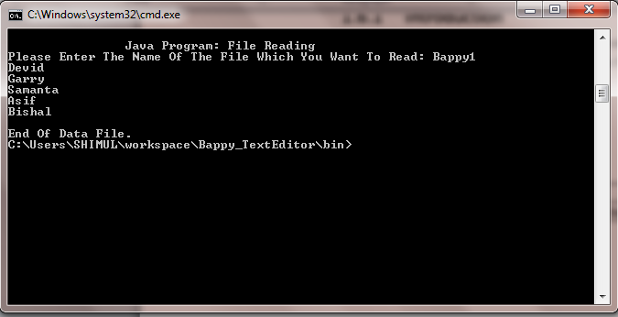

Flow Chart

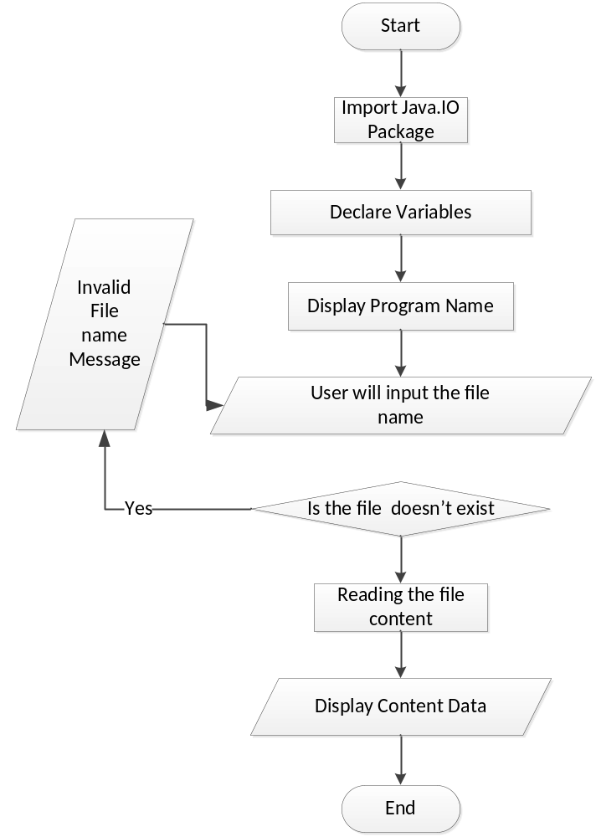

Java Code to Read a File :

import java.io.*;
public class Read {
public static void main(String args[])throws IOException{
BufferedReader br = new BufferedReader(new InputStreamReader(System.in));
System.out.print("\n\t\tJava Program: File Reading");
String FRead;
Loop1:
for(;;){
System.out.print("\nPlease Enter The Name Of The File Which You Want To Read: ");
FRead = br.readLine();
if(FRead.equals("")){
System.out.print("\nYou Did Not Enter Any Valid File Name. Try Again!");
continue Loop1;
}
else break;

}
try{
FileReader fr = new FileReader(FRead);
BufferedReader in = new BufferedReader(fr);
String line = null;
while((line = in.readLine())!=null)
System.out.println(line);
System.out.print("\nEnd Of Data File.");
fr.close();
}
catch(FileNotFoundException e)
{
System.out.print("Error: File Not Found"+e);

}
}

Test Results
Output for test 1
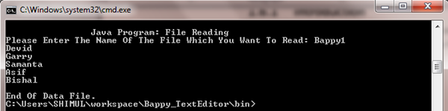
Output for test 2

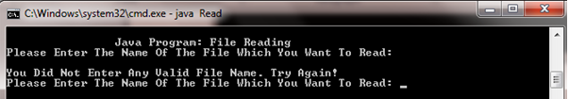

Output for test 3

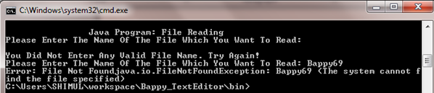

Summarised Test Results:

Test No. | Test Objective | Expected Results | Actual Results | Comments
1. | Valid File Name | No Error | As Expected | Valid Result
2. | Null File Name entry | Error Message | As Expected | Valid Result
3. | File Name Invalid | Error Message | As Expected | Valid Result
Edit Module
Introduction
In MS-DOS prompt when user will access to edit the file, it will first ask which file you want to read.

Edit means Updating any data or information, and to do that we need to read the data first then edit it or add new data in it.

- If the user enters a valid age which is set from 1 to 100, If the age is entered more than 100 then invalid age will appear.
- If the user enters Zero ‘-1’, the record is deleted and the program asks the user to input a new name instead the deleted record.
- If the user enters value more than 100, it shows an error message and asks the user to input a valid value within the set limit.
If the user presses “5” a new record will be added. End of the program it will return the actual edited size of the file.
Then the program will ask if user wants to view the updated or edited file by simply pressing “Y”/”N”.

Input Data
The Following data is used
No. | Data | Purpose
1. | FRead | To store name from which data will be read.
2. | FWrite | To store file name to write data in.
3. | Age | To store age value against each record stored.

No. | Variable Name | Variable Type | Purpose | Example
1. | Data1 | String | To store records from file | FWrite
2. | New name | String | To store new name entered by user. | Devid
3. | Answer | String | To store user’s answer for displaying updated file. | y, n

Screen Layouts.
Input Screen Layout

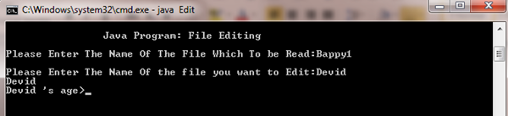
Editing Screen Layout

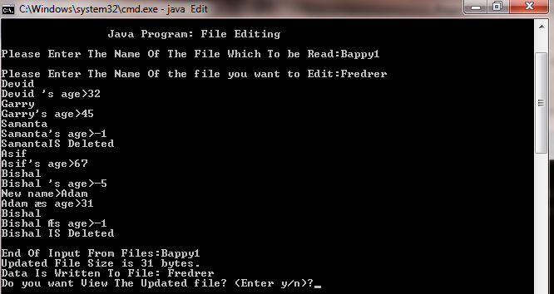
Output Screen Layout
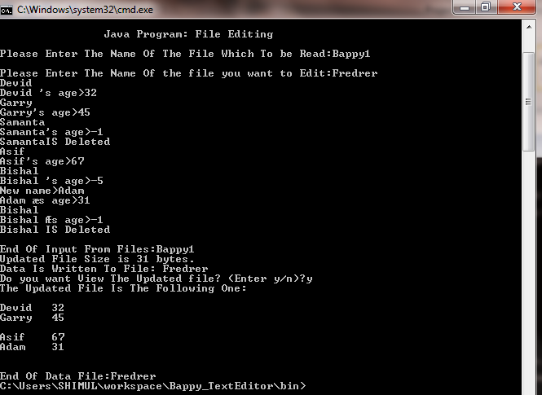

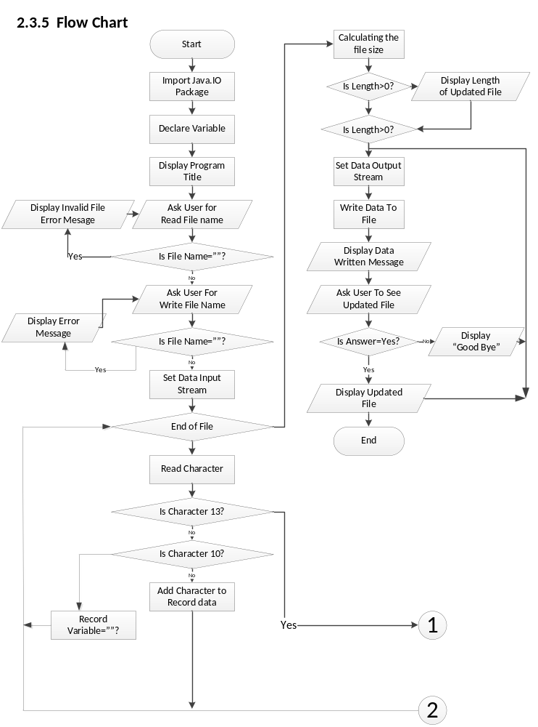

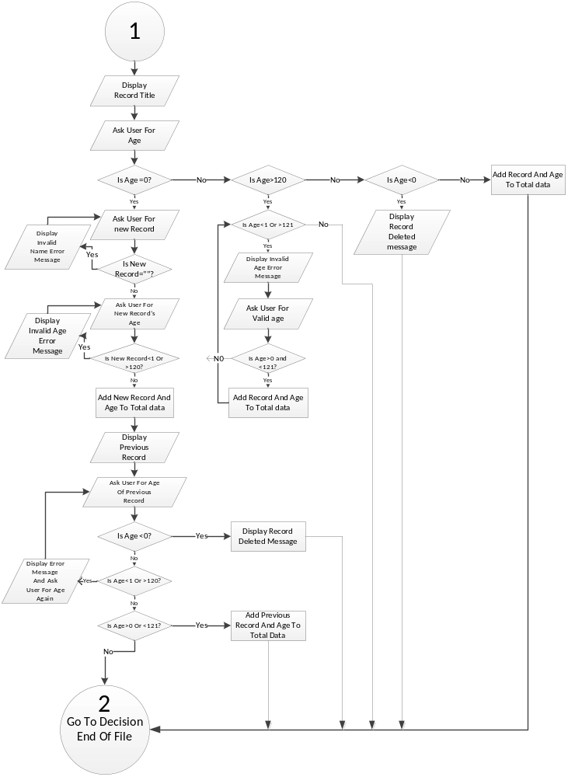

Code Listing
Please note that due to copying code from Java Source file to Microsoft Word documents some of the lines might have been broken to the following line. Hence, attention needed while reading the code documentation.

Java Code for the Edit program:

import java.io.*;
public class Edit {
public static void main(String args[])throws IOException{
BufferedReader br = new BufferedReader(new InputStreamReader(System.in));
System.out.println("\n\t\tJava Program: File Editing");
String FRead;
Loop1:
for (;;){
System.out.print("\nPlease Enter The Name Of The File Which To be Read:");
FRead = br.readLine();
if (FRead.equals("")){
System.out.print("\nYou Did Not Enter Any Valid File Name. Try Again!");
continue Loop1;
}
else break;

}
FileReader fr = new FileReader(FRead);
BufferedReader in = new BufferedReader(fr);
String FWrite;
Loop2:
for (;;)
{
System.out.print("\nPlease Enter The Name Of the file you want to Edit:");
FWrite = br.readLine();
if (FWrite.equals("")){
System.out.print("\n You Did Not Enter Any Valid File Name. Try Again!");
continue Loop2;

}
else break;

}
FileWriter frw = new FileWriter(FWrite);
PrintWriter pr = new PrintWriter(frw);
String line = null;
while ((line = in.readLine())!=null){
System.out.println(line);
int age;
String data1;
for (;;){
try
{
System.out.print(line+"'s age>");
data1 = br.readLine();
age = Integer.parseInt(data1);
}
catch (NumberFormatException e){
System.out.println("Invalid Number, Not integer.Please enter the age again!");
continue;

}
if (age>100){
System.out.println(" Invalid age!\n Please Enter a valid age");
continue;
}
else break;

}
if (age==-5){
System.out.print("New name>");
String line1 = br.readLine();
System.out.print(line1+" ‘s age>");
String S4 = br.readLine();
int age1 = Integer.parseInt(S4);
pr.println(line1+"\t"+age1);
System.out.println(line);
System.out.print(line+"’s age>");
data1 = br.readLine();
age = Integer.parseInt(data1);

}
if (age==-1)
{
pr.print("\r");
System.out.println(line+"IS Deleted");

}
else pr.println(line+"\t"+age);

}
frw.close();
fr.close();
System.out.println("\nEnd Of Input From Files:"+FRead);
FileReader fr1 = new FileReader(FWrite);
BufferedReader in1 = new BufferedReader(fr1);
int Tot = 0;
String line2;
byte ch[];
while ((line2=in1.readLine())!=null){
ch = line2.getBytes();
Tot = Tot+ch.length;
}
System.out.println("Updated File Size is "+Tot+" bytes.");
System.out.println("Data Is Written To File: "+FWrite);
DataInputStream ink = new DataInputStream(System.in);
fr1.close();
System.out.print("Do you want View The Updated file? (Enter y/n)?");
char cr = (char)ink.read();
FileReader fr3 = new FileReader(FWrite);
BufferedReader in3 = new BufferedReader(fr3);
if (cr=='y'){
System.out.println("The Updated File Is The Following One: \n");
String line3 = null;
while((line3=in3.readLine())!=null)
System.out.println(line3);
System.out.print("\nEnd Of Data File:"+FWrite);
}
else
System.out.print("Thats all for today");
fr3.close();

}

}

Test Results
Output test 1

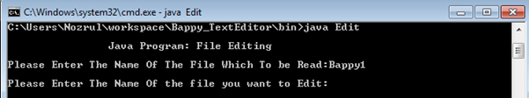

Output Test 2
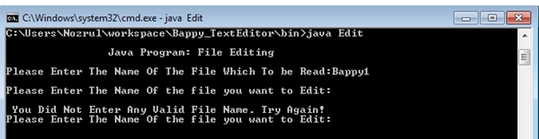

Output Test 3
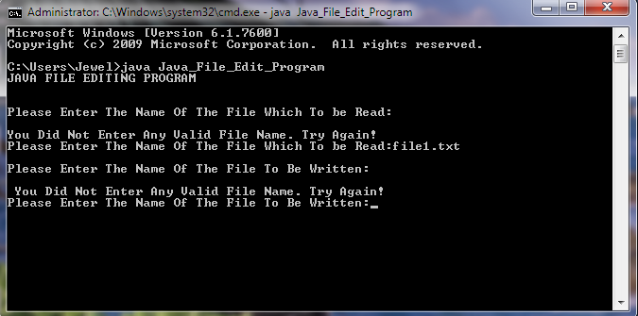

Output Test 4
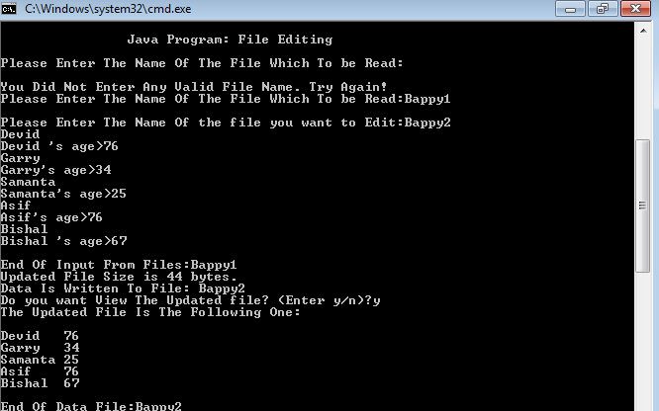

Output Test 5
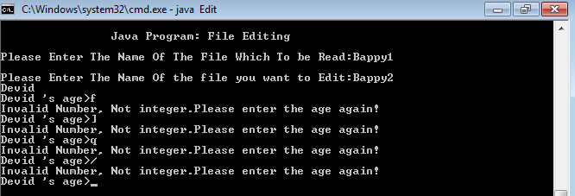
Output Test 6
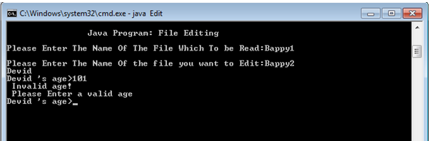

Output Test 7
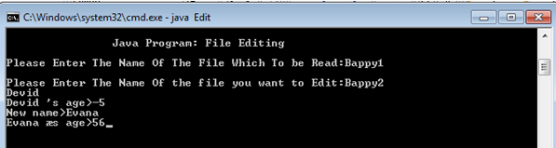

Output Test 8
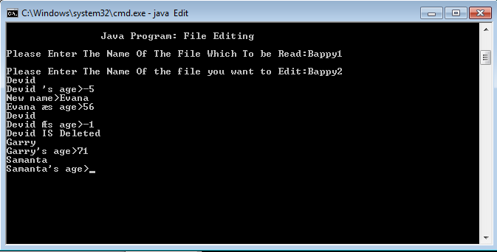

Output test 9
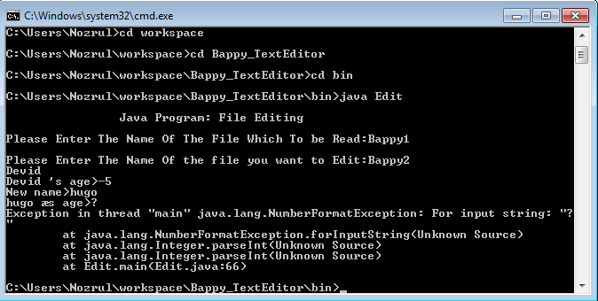

Output test 10

Test Result 11
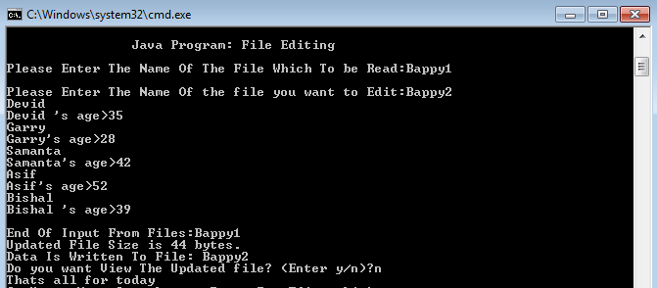

Summarised Test Results
Test Name | Expected Results | Actual Results | Comments
Valid Read File Name | No Error | As Expected | Valid Results
Valid Write File Name | No Error | As Expected | Valid Results
Null File Name Entry | Error Message | As Expected | Valid Results
Null Write File Name Entry | Error Message | As Expected | Valid Results
Valid Record Entry | No Error | As Expected | Valid Results
Null Record Entry | Error Message | As Expected | Valid Results
Above 120 Age Entry | Error Message | As Expected | Valid Results
0 Age Entry | New Name | As Expected | Valid Results
Below 0 Age Entry | Record Deleted | As Expected | Valid Results
Integer New Record Entry | Record Accepted | As Expected | Valid Results
Special Character New Record Entry | Record Accepted | As Expected | Valid Results
Null New Record Entry | Error Message | As Expected | Valid Results
Updated File View Reply ‘y’ Entry | No Error | As Expected | Valid Results
Updated File View Reply ‘n’ Entry | No Error | As Expected | Valid Results
Updated File Reply Null Entry | No Error | As Expected | Valid Results
String Age Input | Error Message | As Expected | Valid Results

Validation

The program has performed accurately with all the test data has given.

Conclusion
Modification can be done with further enhancement using or adding more fields and writing down a whole paragraph.
Limitations and Improvements
Limitations
. Regarding the java text editor we had to use MS-DOS, consequences there is no feasibility to use graphical user interface.

. There is no file extension given so in windows mode every time we had to open and chose the file type.
Improvements
. Improvement can be done by giving user to use graphical user interface.
. Input value can be increased by creating more text fields.

Examiner’s Comment
The following couple of pages are kept blank for any suggestions or comments by the Examiner’s. Thank You.

